KMFINCO
Creating Value That Matters

Malta insights
2026
  - Six practical guides for business owners,
finance leaders and private clients

Tax choices, residence planning, reporting, ownership, VAT and accountable AI.
Sources checked 7 October 2026

Inside this collection
Use these guides to frame the decision, understand the relevant distinctions and prepare the evidence for the next conversation.
Each article includes key takeaways, a visual explanation, a practical evidence checklist and links to the sources.
01 Malta’s 15% FITWI Tax in 2026: How It Compares with the Refund System 3
Tax · 8 minute read
02 Malta Tax Residence in 2026: What Changes on 1 January 2027? 11
Private Client Tax · 9 minute read
03 Malta Audit Exemptions in 2026: Audit, Review Report or Neither? 19
Audit & Assurance · 8 minute read
04 Malta Beneficial Ownership Changes in 2026: Does Your Company Need Form BO4? 27
Corporate Governance · 9 minute read
05 VAT Registration in Malta in 2026: Article 10, Article 11 or Article 12? 37
Tax · 9 minute read
06 AI in Professional Services: Who Signs Off? 45
Management Consulting · 6 minute read
Source references within the articles open the cited publications. Article titles on this page link to their opening pages.
01 / TAX

Malta’s 15% FITWI Tax in 2026: How It Compares with the Refund System
Compare Malta’s elective FITWI regime with the shareholder-refund system: the tax floor, distribution assumptions, cash-flow timing and five-year commitment that should shape a company’s decision.
KMFinco · 8 minute read · Sources checked 7 October 2026


Key takeaways
- FITWI is elective and final, with a statutory floor; 15% is not a universal result for every income stream.
- Compare the company and shareholder together, while keeping their cash flows separate.
- The election commits the entity for five years of assessment, and leaving also has a minimum-period consequence.
- For a 31 December 2025 year-end, the published electronic filing extension is 27 November 2026; payment deadlines are separate.
Malta’s Final Income Tax Without Imputation regime, usually shortened to FITWI, gives qualifying entities an alternative way to be taxed. Its 15% headline is an invitation to compare two systems carefully: the entity’s final liability, the shareholder’s refund position, the timing of cash movements and a commitment extending across several years.
The useful question for a company director is: which framework produces the more appropriate outcome for this business and its owners over the whole commitment period? The answer requires more than comparing 15% with 35%.
This guide explains the general framework checked on 7 October 2026. The examples are hypothetical, with assumptions stated; an election requires a calculation for the particular entity and shareholders.

What FITWI changes
Legal Notice 188 of 2025 created an elective 15% charge on the relevant chargeable income of an eligible entity. Its definition includes companies, certain bodies treated as companies, and specified trusts. The tax is final: it cannot become a shareholder refund or a credit against another person’s Maltese tax liability. Relevant profits are allocated to the final tax account. S1
The ordinary corporate system remains available. MTCA describes a 35% company rate, followed, where the conditions are met, by a refund of part or all of the company tax to shareholders after a dividend distribution. That distinction between the company and its shareholder matters. S2
Question | Ordinary system | FITWI
Where does the comparison start? | Company tax calculation, then the relevant shareholder position. | Eligible chargeable income and the statutory floor.
Can a shareholder refund arise? | Potentially, subject to the applicable conditions. | No refund of the FITWI tax.
What should the cash forecast show? | Company tax, dividends and any later shareholder refund separately. | The entity’s final liability and proposed distributions.
What needs a written decision? | The assumed refund entitlement and distribution plan. | Eligibility, the comparative calculation and the commitment.

Accounting profit is not automatically chargeable income. Begin with the tax computation, including relevant deductions, losses and adjustments, before applying either framework.

The 15% rate has a floor
The regulations prevent FITWI tax from falling below the ordinary-system tax reduced by the shareholder refunds claimed or claimable on the relevant profits, including the adjustment under Income Tax Act Article 43(6), where applicable. A company cannot establish its FITWI liability merely by multiplying an unexamined profit figure by 15%. S1
A practical comparison therefore needs two independently supported calculations. First establish the ordinary-system liability and eligible refunds. Then calculate FITWI and test its floor. A conclusion such as “the shareholders will not submit a refund claim” does not, by itself, settle a rule that also refers to amounts claimable.
Separate excluded income before calculating. The regulations exclude specified dividends from Maltese-company profits not allocated to the distributing company’s final tax account, and income already subject to other final-tax provisions and allocated to that account. Applying 15% to every line in an investment company’s income statement could therefore produce a misleading answer. S1

A worked example: all qualifying profits are distributed
Hypothetical assumptions: a company has accounting profit before tax and chargeable income of €100,000 from ordinary trading; no foreign-tax relief, excluded income or other relevant adjustments; the profits are lawfully distributable and the full after-tax profit is distributed; and the shareholder meets all conditions for a six-sevenths refund. For FITWI, assume eligibility and no floor adjustment above 15%.
Article 48(4A) of the Income Tax Management Act provides the six-sevenths mechanism, with qualifications including the source of the distributed profits, registration and different treatment of certain income. The example assumes those checks have been completed. S3
Calculation | Ordinary system | FITWI
Chargeable income | €100,000 | €100,000
Entity tax in this illustration | €35,000 | €15,000
After-tax profit distributed | €65,000 | €85,000
Eligible shareholder refund | €30,000 | €0
Combined company/shareholder Malta tax after refund | €5,000 | €15,000
Total dividend and refund reaching the shareholder | €95,000 | €85,000

The refund calculation is €35,000 × 6/7 = €30,000. The ordinary-system amount remaining after that refund is €5,000. Consequently, the assumed FITWI charge of €15,000 is above the floor in this example.
There are two different observations. FITWI involves €20,000 less entity tax initially in this simplified comparison. The ordinary system ultimately leaves €10,000 less combined Malta tax after the assumed refund. Neither observation should be presented without the other.
The table excludes foreign shareholder taxation, financing costs, distribution constraints and processing time. It does not imply that every company qualifies for a 5% effective result, that refunds arrive immediately, or that money refunded to a shareholder automatically belongs to the company.

Retaining profits changes the cash-flow question
Consider a second hypothetical business preparing to fund equipment and recruitment. Its owners intend to retain profits instead of distributing them immediately. A model that puts a future shareholder refund into the company’s bank balance today would overstate cash available for that investment.
Prepare a separate cash schedule for the entity and its owners. Show when tax is paid, when dividends can and will be declared, when a refund could be claimed and received, and whether any shareholder money would be reinvested through a documented transaction. Treat uncertain receipt dates as scenarios, rather than promises.
The FITWI alternative still needs the statutory floor calculation. Retention alone is not a sound basis for assuming an unconditional 15% final cost. Where the meaning or timing of a claimable refund affects that comparison, resolve the treatment in the company’s tax analysis before presenting a cash advantage to the board.
This is also a useful way to evaluate administrative simplicity. Estimate the work the business would actually avoid or retain. Compare that with the difference in tax and financing costs. “Fewer steps” has a value, but the value should be explicit rather than assumed to outweigh every other factor.

Make the decision across five years of assessment
MTCA’s March 2026 notice requires the election through the relevant income-tax-return questions and confirms a binding period of five consecutive years of assessment. S4
For an election beginning with YA2026, the initial five-year span is YA2026–YA2030. The regulations continue the regime until a valid notification to leave; they also impose a minimum five-year ordinary-system period following an exit. There is no annual freedom to switch to whichever regime produces the lowest charge that year. S1
Build one decision paper with five parts:
- Define the entities and income. Identify the taxpayer, owners, tax accounts and income streams. Flag proposed acquisitions, disposals or ownership changes that may alter the assumptions.
- Establish the baseline. Reconcile the latest computation to the financial statements. Support each assumed refund fraction and identify who would receive it.
- Compare the relevant years. Use the known first-period figures and reasonable forecasts for subsequent periods. Test a lower-profit case and a change in dividend policy.
- Map cash separately. Distinguish company liquidity from shareholder receipts. Include a sensitivity for refund timing and financing, without inventing a standard processing period.
- Record the decision and implementation. State the chosen approach, material assumptions, responsible approver and actions needed before filing. Retain the calculation with the tax working papers.
Internationally connected businesses should add a separate review of the owners’ jurisdictions and any relevant group obligations. A Maltese headline rate does not establish the worldwide outcome. The comparison should identify where a foreign-tax conclusion has been confirmed and where it remains dependent on facts.

The 2026 filing point
MTCA made the YA2026 corporate return available in May, including a question about FITWI. This makes the election an operational filing issue, alongside the underlying assessment of suitability. S5
For a company whose financial year ended 31 December 2025, the income normally falls within YA2026. MTCA’s published table gives 27 November 2026 as the electronic-return extension for that year-end. It explicitly says electronic filing extensions do not extend tax-payment deadlines. Other year-ends have different entries in the table. S6
Work backwards from the correct filing date: confirm practitioner access, settle the comparison, obtain approval, complete the return and retain the submission acknowledgement. Check payments on their own timetable. The existing tax and finance calendar provides a structure for allocating that work and its supporting evidence.

Questions directors commonly ask

Is FITWI automatically the better choice because 15% is lower than 35%?
No. The 35% figure is the ordinary entity-level starting point. A valid shareholder refund can materially change the combined Malta outcome. Compare both completed calculations and their cash timing, as the worked example illustrates.

Can the business claim a refund of the FITWI tax later?
The regime makes that tax final. The commercial model should therefore show no shareholder refund of the FITWI charge. Any separate tax position outside the illustrated income must be assessed on its own basis. S1

Does every shareholder receive a six-sevenths refund under the ordinary system?
No. The relevant income, tax-account allocation, reliefs, distribution and claimant conditions must be checked. The Act provides different treatment for specified categories, including certain passive interest and royalty profits. The example deliberately assumes one qualifying fact pattern. S3

Can we change the election when our dividend policy changes?
A new dividend policy is a reason to revisit forecasts, but it does not cancel the statutory commitment. Model possible changes before electing and obtain specific advice on any subsequent exit timetable.

Does the November filing extension also delay payment?
No. The cited extension concerns the electronic return. Establish the company’s tax-payment dates separately and verify the filing entry for its actual year-end. S6

Turn the rate comparison into a documented decision
A useful FITWI assessment should leave directors with a clear computation, a cash forecast, a record of the five-year implications and an achievable filing plan. Bring the financial statements, tax workings, ownership information and intended distributions to that discussion.
KMFinco’s Tax, Accounting & Payroll service is a relevant starting point for discussing your company’s position. Where ownership or distributions require coordination, connect the tax analysis with Corporate & Fiduciary work.
Visual guide

€100,000 of qualifying profit: two complete Malta tax outcomes
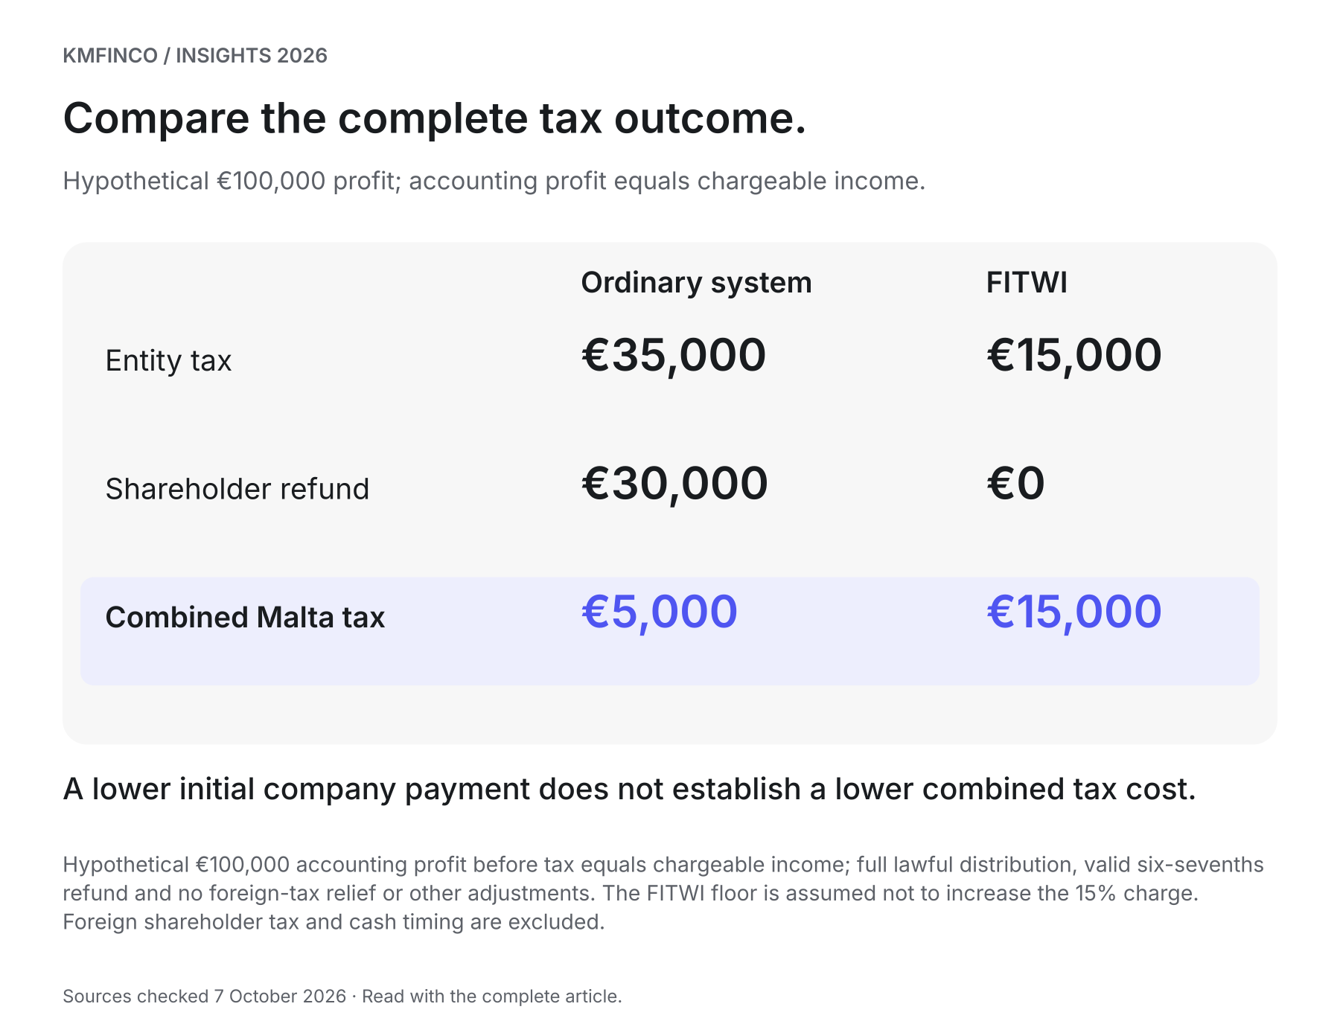
Hypothetical €100,000 accounting profit before tax equals chargeable income; full lawful distribution, valid six-sevenths refund and no foreign-tax relief or other adjustments. The FITWI floor is assumed not to increase the 15% charge. Foreign shareholder tax and cash timing are excluded.
Evidence checklist

FITWI decision file
Prepare one evidence pack before approving an election. This is an original working checklist, not an official filing form.
01 Identify the entity, shareholders and income streams.
Evidence: Ownership chart, latest accounts, tax-account schedule and income analysis.
Suggested owner: Finance lead
02 Establish the ordinary-system baseline.
Evidence: Reconciled tax computation and supported refund entitlement for each relevant shareholder.
Suggested owner: Tax practitioner
03 Calculate FITWI, exclusions and the floor.
Evidence: Comparison showing the statutory calculation and material assumptions.
Suggested owner: Tax practitioner
04 Separate entity and shareholder cash.
Evidence: Tax, dividend, expected refund and reinvestment schedules.
Suggested owner: Finance lead
05 Test the five-year decision.
Evidence: Relevant-YA forecast with profit, ownership and distribution sensitivities.
Suggested owner: Directors and finance lead
06 Confirm election and payment dates separately.
Evidence: Actual year-end deadline entry, practitioner access and payment calendar.
Suggested owner: Tax practitioner
07 Approve and retain the final record.
Evidence: Decision paper, signed approval, filed return and acknowledgement.
Suggested owner: Directors

Sources and further reading
Sources checked 7 October 2026. Source titles link to the original publications.
S1 Final Income Tax Without Imputation Regulations, S.L. 123.217, regulations 2–3 — 2025-09-02; current consolidated text checked 2026-10-07
S2 MTCA: Corporate Tax — Current page checked 2026-10-07
S3 Income Tax Management Act, Chapter 372, article 48(4) and (4A) — Consolidated text checked 2026-10-07
S4 MTCA: Election for Final Income Tax Without Imputation — 2026-03-27
S5 MTCA: Year of Assessment 2026 — Tax Return for Companies — 2026-05-07
S6 MTCA: Income Tax — Company Income Tax Return Cycle — Current deadline table checked 2026-10-07
02 / PRIVATE CLIENT TAX

Malta Tax Residence in 2026: What Changes on 1 January 2027?
Malta’s Individual Tax Programme starts in January 2027. Understand the transition dates, the new financial requirements and the evidence existing beneficiaries and prospective applicants should organise before making a decision.
KMFinco · 9 minute read · Sources checked 7 October 2026

Key takeaways
- The Individual Tax Programme begins on 1 January 2027. Its transition provision covers relevant statuses granted, and applications received, by 31 December 2026.
- The continuation horizon is 31 December 2031, subject to the applicable conditions. An application received before the cutoff is not an approval.
- Under the new rules, global and EU/EEA/Swiss categories have a €35,000 annual minimum tax. Pensioner categories have different treatment.
- Establish the tax programme, immigration route, income profile and qualifying-property position together before committing to a move.
Malta’s Individual Tax Programme comes into force on 1 January 2027. For people who already hold a relevant special tax status, or are considering an application during 2026, the immediate task is to establish which framework applies and what must be completed before year-end.
The transition provision covers relevant statuses granted and applications received by 31 December 2026, with continuation until 31 December 2031, subject to the rules. Those dates create a planning window. They do not make an incomplete application acceptable or guarantee that a person qualifies. S1
A useful decision starts with the applicant’s circumstances: current status, nationality, family, income, property and intended pattern of living. The percentage tax rate comes later.

First, separate three different questions
“Malta residence” can describe different legal and practical positions.
Question | What determines the answer?
Am I tax resident in Malta? | The facts of residence, including presence and personal circumstances.
Do I qualify for a special tax programme? | The programme’s eligibility conditions and the tax authority’s approval.
May I live or work in Malta? | The applicable immigration, residence-registration and employment arrangements.

MTCA explains that tax residence is a question of fact and that a person may also be tax resident elsewhere. Spending more than 183 days in Malta is one relevant test; someone arriving to establish residence may become resident from arrival. A day count alone does not resolve every case. S2
The immigration process is connected but separate. Identità’s current guidance, for example, describes a residence-permit application for qualifying third-country nationals following confirmation under a relevant programme. EU/EEA/Swiss nationals follow a different registration framework. Special tax status does not itself confer citizenship. S4
For a family planning a move, record each answer separately. This helps prevent a property purchase, school decision or employment commitment from being based on the wrong type of approval.

The dates that matter
Date | What it means for planning
31 December 2026 | Cutoff specified for relevant status grants and applications received under the transition provision.
1 January 2027 | Commencement of the Individual Tax Programme Rules, 2026.
31 December 2031 | Continuation horizon stated for the transitional population, subject to the applicable conditions.

Rule 3(3) establishes the transition and the new five-year status cycle, with further five-year renewals available on application. S1
The transition should be assessed against the person’s actual grant and programme. It should not be advertised as a promise that every historic financial condition, fee or property arrangement is frozen in every situation. Equally, an existing beneficiary should not simply assume that the new €35,000 minimum automatically replaces the terms of their current status.
For context, MTCA’s published Global Residence Programme guidance describes a €15,000 annual minimum for that existing programme. That is a programme-specific figure, rather than a general minimum for every person resident in Malta. S3
Ask for a written comparison that identifies the present rules, the transition relied upon, any proposed change of category and the position expected after 2031.

Choose the starting point that matches you

You already hold special tax status
Find the original grant, subsequent correspondence and the most recent annual compliance records. Confirm the precise programme and who is included in the approved household.
Then identify changes since approval: a different property, a dependant’s circumstances, a new source of income, altered travel patterns or a change in immigration status. Those changes may be more consequential than the headline reform.
Your immediate output should be a short status note: what you hold, why the transition applies, the conditions you must continue to meet and the next review date. Keep routine filings and payments on the calendar while that review takes place.

You are preparing a 2026 application
Start with eligibility and a completeness review through the appropriate authorised registered mandatary. Working backwards from the cutoff is useful only when the documents and facts support the intended route.
The existing GRP procedure illustrates why submission needs care: MTCA checks the application and supporting documents, acknowledges progress through the mandatary and identifies omissions that prevent further processing. S3
Keep evidence of what was submitted and when the authority received it. A draft held by an adviser, an appointment booking or a planned courier collection is not the same evidence as receipt by the authority. Resolve any uncertainty about the status of a submission before relying on the transition.

You are planning a move from 2027
Build the plan around the new framework and your actual category. Compare its annual commitments with your expected income and family spending, then coordinate the immigration and property work.
If relocation is likely to last beyond one status term, include the renewal point in the budget and planning horizon. The first application is only one part of the decision.

What the new programme provides
The new rules create four categories. Their income and minimum-tax treatment must be read with the full eligibility conditions. Applicants must also be non-domiciled in Malta, without intending to establish domicile there within five years of application. S1
New category | Main treatment of qualifying foreign income received in Malta | Annual minimum tax specified
Global resident | 15% | €35,000
EU, EEA or Swiss resident | 15% | €35,000
Retired pensioner | 15%, with pension-specific eligibility | €15,000
UN pensioner | Qualifying UN pension or widows’/widowers’ benefit exempt; 15% on other qualifying foreign income | €20,000 on the relevant non-UN foreign income

The global, EU/EEA/Swiss and retired-pensioner minima are payable in full in the grant and cessation years. Do not assume a late-year approval produces a proportionate reduction. S1
The retired-pensioner category requires the documented pension to be received entirely in Malta and to constitute at least 75% of chargeable income. For the UN category, at least 40% of the relevant pension or benefit must be received in Malta. These are distinct routes, so a pension should be classified before applying a general comparison. S1
Other taxable income covered by rule 5(3) is charged separately at 35%. Classify each person’s income: eligibility as a dependant does not necessarily confer the same tax treatment. S1
Prepare an income schedule by person, country, type, tax year and intended remittance. Separate income from capital transfers and record the evidence supporting that classification. This makes the discussion more useful than a single estimate of the money expected to enter a Maltese bank account.

Property, fees and the annual commitment
The standard new qualifying-property thresholds are €700,000 to purchase or €14,000 annual rent, for property in Malta or Gozo occupied as the beneficiary’s primary residence. The application fee is €8,500, with €2,500 for a renewal application. These administrative fees are non-refundable. S1
There is a specific provision for property purchased by a beneficiary before or up to commencement below the new purchase threshold, with its treatment to be determined through the Commissioner’s guidelines. It should not be converted into a blanket claim that every earlier purchase qualifies. Before relying on it, establish the purchaser, acquisition date, consideration, use and applicable guidance.
A practical budget separates the categories:
- Tax: the relevant annual computation and minimum.
- Property: rent or purchase funding, with acquisition and running costs considered separately.
- Application and administration: official fees and agreed professional fees.
- Living arrangements: insurance, family costs and other commitments.
This prevents an application fee from being mistaken for the programme’s full cost.

Hypothetical illustration: why 15% is not the whole answer
Assume an approved new global-resident beneficiary has €100,000 of foreign income within the 15% treatment, received in Malta. Assume no other taxable income, no relevant double-tax relief and no additional household income.
Fifteen per cent of €100,000 is €15,000. With the €35,000 minimum applying, the amount in this simplified example is €35,000.
If the same assumptions apply to €300,000 of relevant income, 15% is €45,000, above the minimum.
These examples explain how the floor works; they do not assess eligibility or the tax treatment of a particular remittance. A personal comparison must also address foreign-country taxation and available relief.

Turn the decision into a manageable plan
Create one working file with a named person responsible for each outstanding item.
Establish the starting position. Put the tax-status letter, tax numbers, passports and immigration documents together. Record the information still missing rather than treating an assumption as a fact.
Map the household and income. List who will move, who will remain elsewhere, the source of each person’s income and any continuing business responsibilities abroad. Use this to identify questions requiring advice in another jurisdiction.
Check property before commitment. Ask the mandatary to assess the intended property against the applicable programme. Keep the actual deed or lease and evidence of occupancy, rather than relying on a property listing.
Agree the application sequence. Identify documents requiring third-party issuance, certification or translation. Set an internal completion date that leaves time to correct omissions and record receipt.
Plan for continuing compliance. The new rules contain ongoing conditions and cessation provisions covering matters including qualifying property, insurance, representation and relevant residence circumstances. S1 Put the resulting actions into the same calendar as tax filings and payments.
For families, this file should also explain who makes decisions if the principal applicant is unavailable. Our family-wealth governance article discusses how clear roles support longer-term decisions.

Frequently asked questions

Does an application received by 31 December guarantee approval?
No. The transition expressly includes applications received by that date, but the applicant must still qualify. Preserve receipt evidence and address deficiencies through the authorised representative; do not confuse acknowledgement with a grant of special tax status. S1 S3

Does the €35,000 minimum apply to everyone living in Malta?
No. It is the minimum specified for the new global and EU/EEA/Swiss categories. Other programme categories have different treatment, and ordinary Maltese tax residence is a separate analysis. Existing beneficiaries need a review of their own transitional position. S1 S2

Can I keep a property purchased for less than €700,000?
Possibly, but the answer cannot be determined from the purchase price alone. The new rules contain a provision for certain earlier purchases subject to the Commissioner’s guidelines. Check its application to the particular beneficiary and property before relying on it. S1

Is the programme right for someone spending fewer than 183 days in Malta?
A day count does not establish suitability. Tax residence, programme conditions, primary residence, time elsewhere and foreign-country obligations must be considered together. A person’s actual arrangements should support the position taken. S1 S2

Make the next decision with the right facts
Start with a documented comparison of your current position and intended move. KMFinco’s Tax, Accounting & Payroll and Investment & Family Office teams provide relevant starting points for discussing the tax and family-planning questions and coordinating the appropriate professional input.
General information checked on 7 October 2026. Application outcomes and individual tax treatment depend on the applicable rules and the person’s circumstances.
Visual guide

The Malta tax-programme transition: three dates
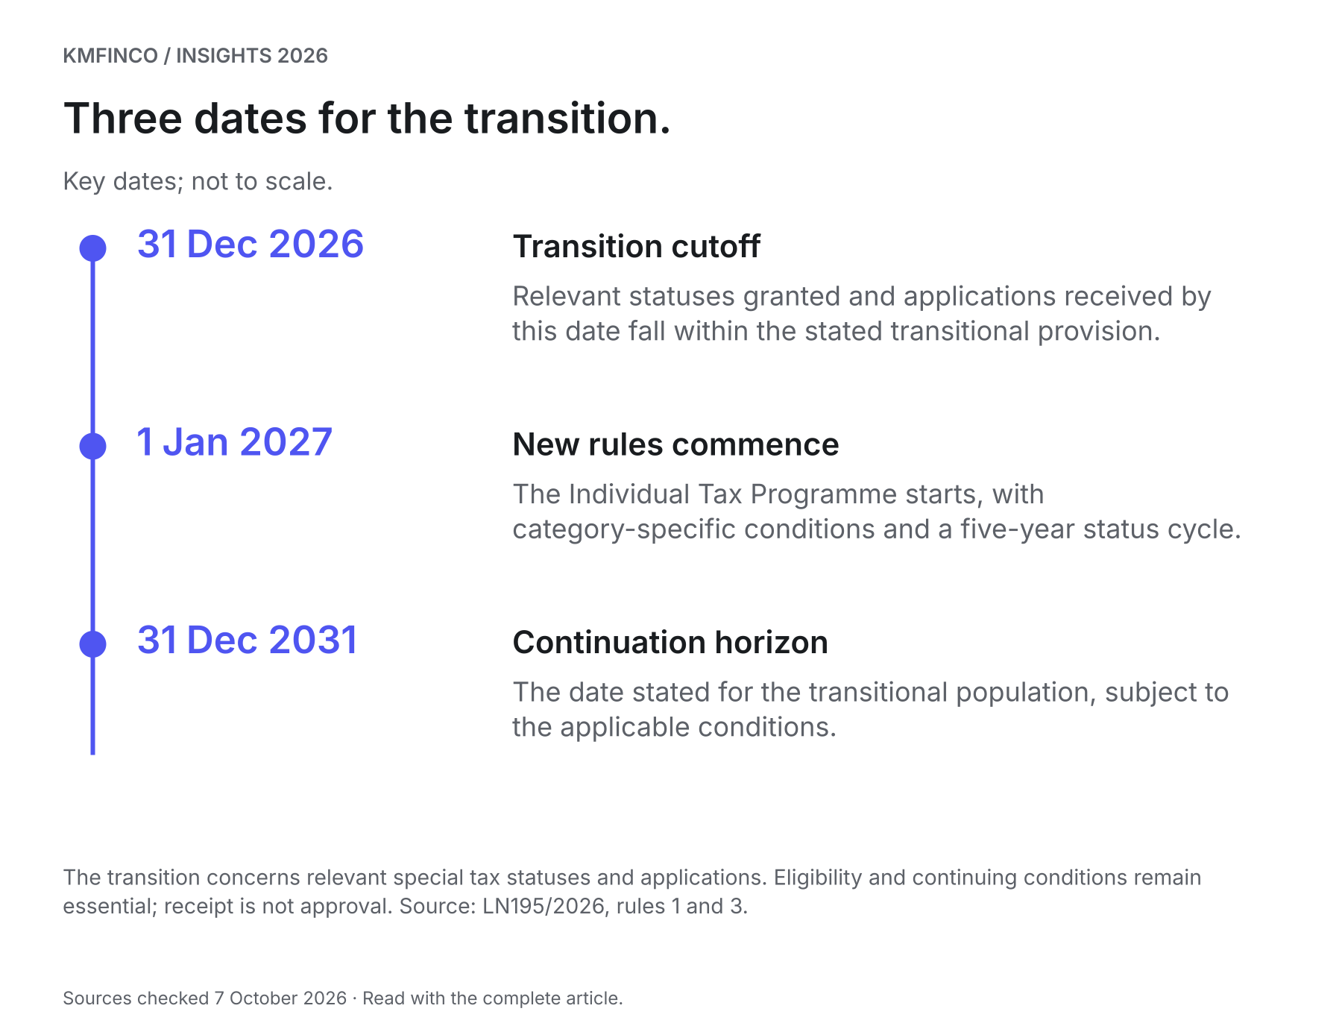
The transition concerns relevant special tax statuses and applications. Eligibility and continuing conditions remain essential; receipt is not approval. Source: LN195/2026, rules 1 and 3.
Evidence checklist

Your Malta tax-residence preparation record
Use this original planning checklist to organise the facts for a programme assessment. It is not an application form or eligibility certificate.
01 Identify the current tax status and any existing programme.
Evidence: Grant letter, tax number, later correspondence and current compliance record.
Suggested owner: Applicant and tax adviser
02 Confirm the intended application category and transition relied upon.
Evidence: Dated programme comparison referring to the relevant rule and the applicant's facts.
Suggested owner: Authorised registered mandatary
03 List household members and their circumstances.
Evidence: Identity, relationship, dependency and relevant residence documents.
Suggested owner: Applicant
04 Classify expected receipts by person and source.
Evidence: Income schedule, pension documents, investment statements and records distinguishing income from capital.
Suggested owner: Applicant and tax adviser
05 Check the intended property against the applicable programme.
Evidence: Deed or lease, consideration or rent, acquisition date and documented assessment of any earlier-purchase provision.
Suggested owner: Applicant and authorised representative
06 Coordinate the immigration and employment position.
Evidence: Relevant permit or registration route, current documents and actions for each family member.
Suggested owner: Appropriate immigration adviser
07 Complete and record the application sequence.
Evidence: Document list, reviewed submission copy, receipt acknowledgement and unresolved-query log.
Suggested owner: Authorised registered mandatary
08 Budget and diary continuing requirements.
Evidence: Annual budget separating tax, property, official fees and other costs; assigned filing and review dates.
Suggested owner: Applicant and adviser

Sources and further reading
Sources checked 7 October 2026. Source titles link to the original publications.
S1 Individual Tax Programme Rules, 2026 — Legal Notice 195 of 2026 — 2026-07-14
S2 MTCA — Tax Residence — 2025-08-29
S3 MTCA — Global Residence Programme Guidelines, Version 2.0 — Version 2.0; accessed 2026-10-07
S4 Identità — Economically Self-Sufficient Residence Permit FAQs — Accessed 2026-10-07
03 / AUDIT & ASSURANCE

Malta Audit Exemptions in 2026: Audit, Review Report or Neither?
A practical guide to Malta’s separate company-size and audit-exemption tests, the tax review-report route, and the evidence directors should assemble before changing their reporting arrangements.
KMFinco · 8 minute read · Sources checked 7 October 2026


Key takeaways
- Small-company classification and audit exemption use different tests. Turnover below €10 million is not a general exemption from audit.
- An eligible company may still need an ISRE 2400 review for tax purposes even when a Companies Act audit exemption applies.
- The reporting period, previous periods and any relevant group position can change the answer.
- Agree the required accounts, report, declarations and filing responsibilities before changing the engagement.
A Malta company may qualify for an exemption from statutory audit and still need a professional review report for tax purposes. Another may be exempt from both reports under the relevant tax route. Neither conclusion follows simply because the business is described as small.
For directors, the useful starting point is a short reporting assessment that connects the company, its accounting period and its legal obligations. That assessment should precede any decision to cancel an audit, commission a review or change what is filed.
This guide covers the ordinary private-company route as understood on 7 October 2026. It is general information; the company's facts and applicable requirements determine its reporting position.

Start with three separate questions
What accounts must the company prepare? What assurance is required? What must be delivered, and to whom? These questions are related, but answering one does not resolve the others.
Malta's Audit Exemption Rules recognise specified exemptions for income-tax purposes without removing audit obligations imposed under other legislation. MTCA's guidance expressly preserves that distinction. S3
Use a reporting matrix with a separate line for the Companies Act, income-tax requirements and any additional sector or contractual obligation. For each line, identify the relevant period, required document, intended recipient and person responsible. This makes a disagreement about “whether we need an audit” easier to resolve: the parties may be discussing different obligations.
The question is particularly relevant to current compliance work. MTCA's YA2026 company-return announcement identifies additional wording dealing with the Audit Exemption Rules. The reporting assessment therefore needs to connect with the return actually being prepared. S6

Do not mix the two threshold sets
Article 185 contains different figures for different purposes. The distinction should remain visible in any briefing to the board.
Test | Balance-sheet total | Net turnover | Average employees | Purpose
Article 185(1) | €5,000,000 | €10,000,000 | 50 | Small-company classification under the relevant provisions
Article 185(2) | €46,600 | €93,000 | 2 | Separate private-company audit-exemption criteria

The statutory tests use limits that are not exceeded, and involve at least two relevant criteria. Article 185 also addresses changes across accounting periods and parent-company circumstances. S1
A director should therefore be wary of an assessment that starts and ends with annual sales. Ask which paragraph is being applied, where the balance-sheet and employee figures came from, and which other conditions have been checked.

Establish the reporting period before using the 2026 figures
MBR states that the revised company-size thresholds apply to financial reporting periods starting on or after 20 March 2026. It prohibits early or retrospective application. S2
For example, an ordinary calendar-year period beginning on 1 January 2026 began before that date. A twelve-month period beginning on 1 April 2026 began after it. The date on which the accounts are signed or the adviser reads this article does not change those start dates.
There is another commencement date to keep separate: the ordinary tax route in rule 6 applies to accounting periods commencing on or after 1 January 2025. The Audit Exemption Rules were enacted in 2025; they are not a new general audit waiver introduced for all companies in 2026. S4
Write the accounting-period start, period end and year of assessment at the top of the working paper. This small administrative step prevents advice intended for one period from being carried into another.

How the ordinary tax route works
For an eligible company benefiting from the Article 185(2) exemption, MTCA's guidance distinguishes two outcomes. Meeting two relevant criteria can permit a review report in place of the statutory audit report for the specified tax requirement. Meeting all three can permit exemption from both reports. The guidance illustrates the assessment over consecutive periods and in group situations. S3
If the company does not establish that it qualifies, it should not replace its existing audit arrangement on the strength of a threshold calculation alone. First resolve the missing facts and the applicable route.
The history matters. The rules refer to Article 185(3), which addresses changes over two consecutive accounting periods after the first balance-sheet date. A first period requires its own assessment; “every company must have traded for two years before any exemption” is not an accurate universal shortcut. S4

Two illustrative companies: the employee figure changes the question
The following companies are fictional. Assume each is an ordinary Malta private company, has no relevant group or sector complication, has unchanged circumstances over the two periods shown, and satisfies the other conditions for the ordinary route. These examples explain the comparison; they are not individual eligibility determinations.
Company and measure | Previous period | Current period
Harbour Studio: balance-sheet total | €32,000 | €39,000
Harbour Studio: net turnover | €72,000 | €87,000
Harbour Studio: average employees | 3 | 3
Island Desk: balance-sheet total | €29,000 | €36,000
Island Desk: net turnover | €68,000 | €84,000
Island Desk: average employees | 1 | 2

Harbour Studio stays within the asset and turnover limits but exceeds the employee limit in both periods. Its file points towards the review-report route, assuming the stated eligibility conditions hold. Calling it completely exempt would overlook the third measure.
Island Desk stays within all three limits in both periods. Its file points towards the route with neither audit nor review for the specified tax requirement, again subject to the assumptions. The distinction is consistent with MTCA's published framework. S3
Now change one fact: suppose Island Desk has just acquired a subsidiary. The figures above no longer provide a complete assessment. The structure and relevant group conditions must be examined before the earlier conclusion is carried forward. Likewise, a single current-year movement should be assessed against the applicable transition rule, rather than treated as an automatic switch.

Group circumstances and special routes need their own assessment
A parent company's standalone balance sheet may tell only part of the story. Where the relevant consolidation requirement applies, rule 6(2) links the relief to the group's continuing small-group qualification. Establish the structure, the applicable consolidation position and the correct period-specific figures. S4
Ask for the ownership chart and the subsidiaries' financial information early. Missing group records discovered just before a filing deadline can turn a simple engagement into an urgent reconstruction exercise.
There are also separate provisions for qualifying newly registered companies and companies under the Merchant Shipping Act. MIA's guidance discusses those routes separately. A newly formed business or a company connected with shipping should not assume that its description establishes eligibility. S5

What a review report actually provides
An ISRE 2400 review is a limited-assurance engagement. It involves less extensive procedures than an audit and does not express an audit opinion. It is still professional assurance work with an evidence-supported conclusion. S7
From a director's perspective, the engagement discussion should establish the financial statements being reviewed, their reporting framework, the information required and the report's intended users. “Review” should not be understood as a quick editorial check of accounts already prepared.
A tax-purpose report may also have a restricted audience. MIA recommends a restriction-of-use paragraph where the review is undertaken solely for MTCA and the report is not intended for general use. Before forwarding it to a lender or investor, check its terms and that recipient's actual requirement. S5

Turn the conclusion into an orderly year-end plan
A useful assessment ends with an agreed sequence of work. Assemble the period dates, reconciled financial figures, employee calculation, earlier reporting position, ownership structure and any additional reporting commitments. Record where each item came from and who confirmed it.
Then agree the engagement and filing plan. Specify who prepares the accounts, who performs any assurance work, which declarations accompany filings, and who checks acceptance. Keep the company's board approval and the practitioner's reporting responsibilities clear.
MIA confirms that the Audit Exemption Rules do not change the applicable financial-statement preparation framework. An exemption should therefore trigger a revised reporting plan, rather than the abandonment of the accounting process. S5
Use the same plan to anticipate growth. If hiring, an acquisition or a change in activity may alter next year's position, budget for the assessment and records needed. Good bookkeeping remains valuable when a company moves between assurance levels.

Frequently asked questions

Does turnover below €10 million mean no audit is required?
No. That figure belongs to the small-company classification shown above. The private-company audit exemption and tax reporting route require a separate assessment.

Can we use last year's conclusion again?
Use it as a starting point, then update the facts. Confirm the period, figures, structure and relevant changes. Record why the previous conclusion continues to apply or why it changes.

Can an eligible company still choose assurance?
Yes, but agree its purpose and audience first. A lender's requirement, an investor discussion or a planned transaction may justify a separate engagement. Confirm exactly what the recipient needs before commissioning work.

Is this the same as internal audit?
No. This guide concerns assurance and reporting connected with financial statements and tax records. Internal audit planning addresses a separate programme of work on governance, risk and controls.

Bring the facts to the reporting discussion
The most productive first conversation starts with the company's records and reporting period. KMFinco's Audit & Assurance and Tax, Accounting & Payroll service areas provide the relevant starting points for discussing the assessment and resulting work.
For a practical way to organise responsibilities and evidence, read Creating a more connected tax and finance calendar.
Visual guide

Two tests. Different purposes.
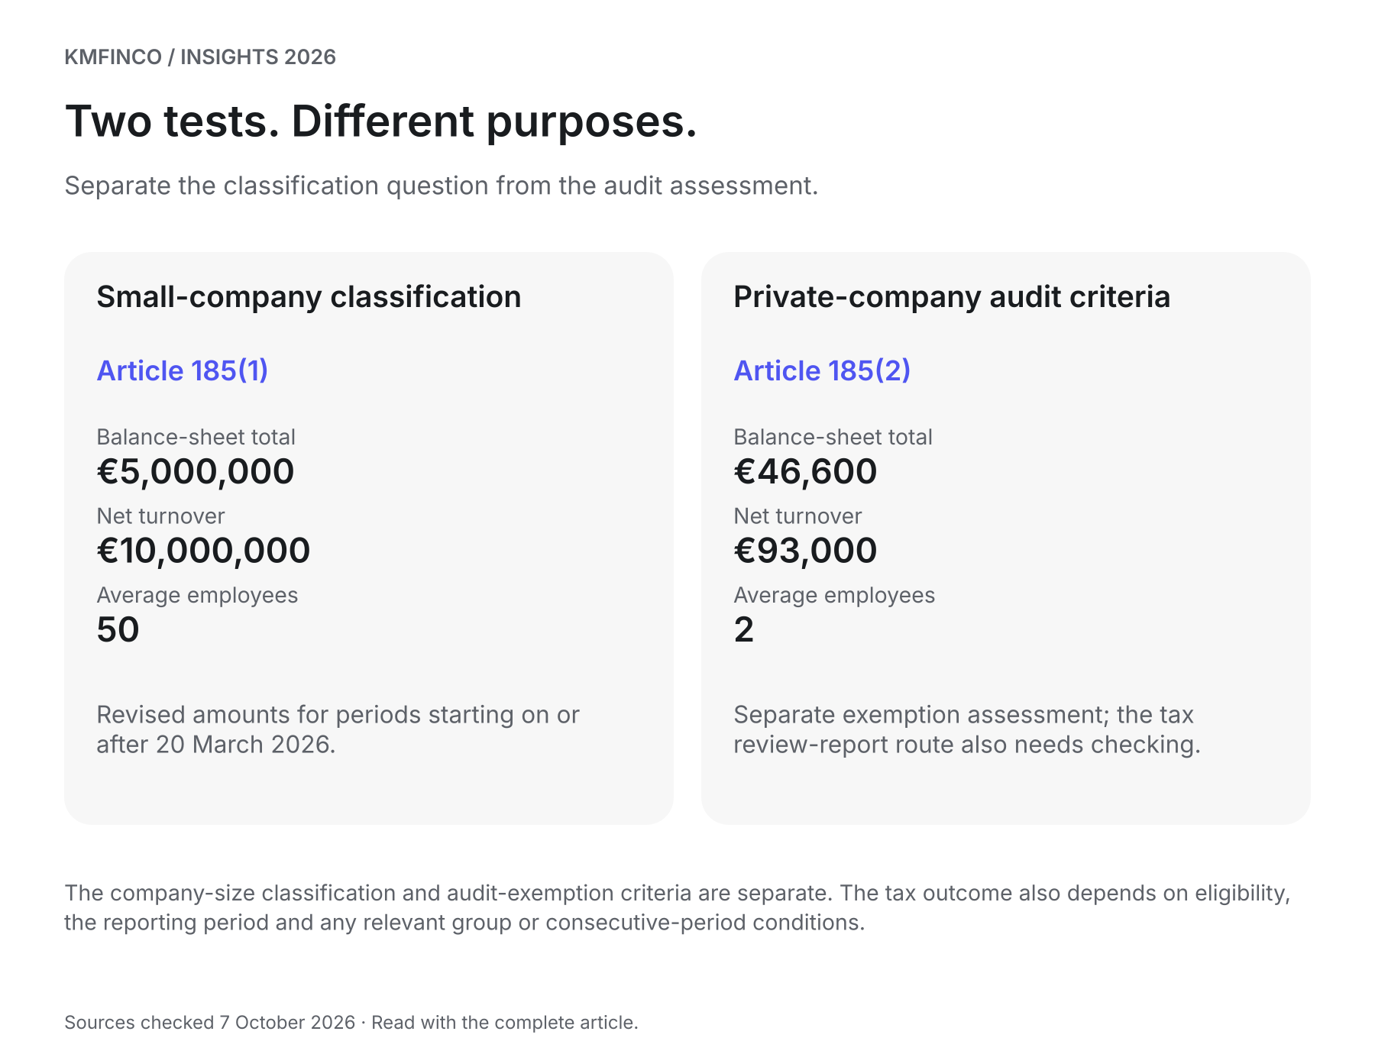
The company-size classification and audit-exemption criteria are separate. The tax outcome also depends on eligibility, the reporting period and any relevant group or consecutive-period conditions.
Evidence checklist

Prepare your audit-or-review assessment
Bring this evidence to the reporting discussion. It supports an assessment; it does not establish eligibility by itself.
01 Identify the entity and reporting period
Evidence: Registered company details; period start/end; year of assessment; activity and any sector status
Suggested owner: Director / finance lead
02 Reconcile the relevant figures
Evidence: Current and comparative accounts; assets and net-turnover reconciliations; employee calculation
Suggested owner: Finance lead
03 Record the existing reporting position
Evidence: Prior report; previous exemption assessment; relevant earlier periods
Suggested owner: Finance lead / reporting adviser
04 Check the structure and consolidation position
Evidence: Ownership chart; subsidiary information; period-appropriate group assessment
Suggested owner: Director / reporting adviser
05 Map each recipient's requirement
Evidence: Companies Act, MTCA, sector, lender and investor reporting matrix
Suggested owner: Reporting adviser / director
06 Agree the engagement and filing plan
Evidence: Required report and intended users; engagement terms; declarations; due dates and owners
Suggested owner: Director / practitioner
07 Document the conclusion and recheck triggers
Evidence: Dated assessment; responsible approver; hiring, acquisition or other changes to monitor
Suggested owner: Director / finance lead

Sources and further reading
Sources checked 7 October 2026. Source titles link to the original publications.
S1 Companies Act, Chapter 386, Article 185 — Consolidated text checked 2026-10-07
S2 MBR: Informative Note – Entry into force of legislation — 2026-03-26
S3 MTCA: Guidelines in relation to the Audit Exemption Rules — Checked 2026-10-07
S4 Legal Notice 139 of 2025: Audit Exemption Rules — 2025-07-15
S5 MIA: Guidance Note on Audit Exemption, version 1.0 — 2026-04
S6 MTCA: Year of Assessment 2026 – Tax Return for Companies — 2026-05-07
S7 IAASB: Revised standard on review engagements — 2012-09-27
04 / CORPORATE GOVERNANCE

Malta Beneficial Ownership Changes in 2026: Does Your Company Need Form BO4?
Malta’s beneficial-ownership rules changed in July 2026. Work through the simplified-regime conditions, identify the relevant BO4 transition and keep the assessment separate from annual confirmations and later ownership changes.
KMFinco · 9 minute read · Sources checked 7 October 2026


Key takeaways
- Companies within the rules formed before 10 July 2026 must assess whether the simplified approach applies. The six-month transition has a calendar endpoint of 10 January 2027.
- All four simplified-regime conditions must hold. A register listing only individuals is not sufficient evidence by itself.
- Where the simplified approach applies, the register of members serves as the beneficial-owners register and the specified separate BO reporting is disapplied while the conditions continue.
- BO4, changes in beneficial ownership and annual BO confirmation address different events. An ordinary company annual return remains a separate obligation.
A Maltese company’s shareholder list is a starting point for understanding beneficial ownership. It does not always show who ultimately owns the economic interest or controls the decisions.
The 2026 amendments make that distinction especially relevant. They introduced Form BO4, additional identifying particulars and a simplified approach for qualifying structures. The practical question for directors is whether the company meets every condition for that approach and what the conclusion means for its filings.
For companies within the rules that were formed before 10 July 2026, the current consolidated text requires an assessment within six months of that date. The calendar endpoint is 10 January 2027. That assessment does not mean every company must file BO4. S1

Start with the current rules
Legal Notice 184 of 2026 introduced the July changes. The consolidated regulations now also incorporate Legal Notice 226 of 2026, including the wording that identifies companies formed before 10 July for the transitional assessment. Use the current consolidation when reviewing the position; a July announcement alone does not show every subsequent correction. S1 S2
First establish that the entity falls within these regulations. There is, for example, a specific exclusion for certain listed companies and companies indirectly fully owned by qualifying listed companies. The rules also extend, with the necessary adaptations, to specified commercial partnerships. S1 S3
For an ordinary private company, the useful output is a recorded conclusion covering:
- The ownership and control facts.
- Whether all simplified-regime conditions are met.
- The transitional form and ongoing notices, if applicable.
- The evidence, responsible officer and completion date.

The four conditions work together
The simplified approach under the first proviso to regulation 5(3) depends on all four limbs being satisfied.
Condition | What the company needs to establish
Individual shareholders | Every registered shareholder is a natural person.
No fiduciary holding | None of those individuals holds the shares as trustee or in another fiduciary capacity.
No undisclosed ultimate owner or controller | No person outside the register of members ultimately holds the relevant ownership or voting interest, or controls the company through other means.
Senior-managing-official limb | The beneficial-ownership analysis does not require identification through the senior-managing-official fallback.

The ownership limb refers to more than 25% of voting rights or other ownership interests, while also capturing control through other means. These are cumulative tests for the simplified approach, rather than a choice between four alternatives. S1
Where the approach applies, the register of members is treated as the beneficial-owners register. MBR explains that the relevant separate BO declarations and notices are then inapplicable, and its guidelines confirm that annual BO confirmation is disapplied while the conditions remain satisfied. S2 S3

“Senior managing official” needs careful interpretation
The reference to senior managing officials can easily be misunderstood. It does not mean that a company fails simply because it has an employee called a manager or a director who runs the business.
The beneficial-owner definition in Malta’s money-laundering regulations provides a fallback when all possible means have been exhausted, no beneficial owner has been identified and there are no grounds for suspicion. In that situation, the relevant senior managing official or officials are identified, and the search and difficulties must be recorded. S4
BO4’s prescribed wording reflects this distinction: it offers a section for identified beneficial owners and a separate section for the senior-managing-official position, with an explanation of why those officials have been identified. S1
An incomplete ownership file is not a reason to choose the chief executive and stop asking questions. Establish the underlying facts first. Where the evidence is inconsistent or creates suspicion, escalate the issue through the appropriate professional process.

Three hypothetical structures
These examples illustrate the assessment. They assume an existing private company within the regulations and no additional facts that change the analysis.

1. Two individuals hold the shares for themselves
Mara and Daniel are registered as equal shareholders. Each holds the economic interest for themselves, neither acts in a fiduciary capacity, no other person controls the company and the beneficial owners can be identified without the fallback.
On those assumptions, the simplified conditions are met. The company should record its assessment and maintain the supporting register. It should review the conclusion if an ownership, voting or control arrangement changes.

2. One registered shareholder acts for another person
Mara and Daniel still appear as equal shareholders, but Mara holds her shares as nominee for Elena.
The visible register has not changed, yet the fiduciary and undisclosed-interest questions produce a different result. The structure cannot be treated as simplified merely because both registered shareholders are individuals. The record must identify the relevant underlying ownership and the nominee arrangement, and the applicable BO4 position must be addressed.

3. No one exceeds the percentage threshold
Four people each hold 25%, with no different voting allocation identified.
That arithmetic does not, by itself, prove that the company has no beneficial owner. The review must examine control through other means, including relevant agreements and appointment rights. If the proper enquiries identify no beneficial owner and the fallback conditions are satisfied, the senior-managing-official position becomes relevant. S4

When does BO4 apply?
Regulation 5(6) addresses an existing company to which the simplified approach does not apply. It requires conformity with the regulations and delivery of the prescribed form, followed by the relevant later notices and declarations. S1
The clear practical case highlighted in MBR’s July notice is a company with only individual registered shareholders that fails one of the remaining conditions. That company should assess and prepare the BO4 filing within the transition. S2
Do not assume that an existing beneficial-ownership filing removes the need for the new assessment. The current regulation is broader in its wording than the natural-shareholder example in the July notice. A company with corporate shareholders, or one already reporting under the ordinary regime, should document its position against the full current text and obtain clarification of the required transitional submission where needed. A company shareholder does not satisfy the first simplified condition.
Set an internal completion date comfortably before the January endpoint. Allow time to resolve contradictory information, obtain identity evidence, secure the officer’s signature and deal with a filing query. The transition should not become a reason to postpone an ownership change that already has its own notification deadline.

Use the form that matches the event
The current MBR forms catalogue separates the following documents. S5
Event | Relevant document or step
Initial 2026 transitional assessment leads to a required declaration | BO4, under regulation 5(6).
Beneficial ownership changes in a company outside the simplified approach | BO2, under regulation 6.
Company reaches its registration anniversary and annual BO reporting applies | Annual Confirmation BO Form, under regulation 6A(1).
The identified senior managing officials change | Change in Senior Managing Officials Form, under regulation 6A(3).
Identifying details change | Change in Details of BO/SMO Form, under regulation 6A(4), as applicable.

For reportable changes under regulation 6(1), the notice is due within 14 days after the change is recorded with the company. The identified-SMO change provision also uses a 14-day period from recording. Annual BO confirmation, where applicable, is due within 42 days after the date to which it is made up. S1
MBR’s annual-filings guidance separately identifies the company annual return and the annual beneficial-ownership confirmation where applicable. A company eligible for the simplified BO approach should therefore keep its ordinary corporate annual-filing calendar. S6

Update the evidence before filling the boxes
The amendments expanded the information to include place of birth, residential address and relevant nominee-shareholder information, alongside existing identity and ownership particulars. They also reinforced the need to identify control beyond registered shareholding. S3
Prepare the record in four layers:
The structure. Reconcile the register of members with the constitutional documents, share movements and voting arrangements. Trace any indirect holdings to the relevant individuals.
The control arrangements. Review shareholder agreements, nominee or trust documents and rights over appointments or decisions. Record why a particular right does or does not establish ultimate control.
The people. Check names, identification details, nationality, residence and the new particulars against suitable evidence. Resolve differences in spelling or dates rather than copying inconsistent information into separate forms.
The history. Record when a person became or ceased to be a beneficial owner, or when the nature or extent of the interest changed. This supports both the internal record and the correct event-based filing.
Use MBR’s current forms catalogue when preparing the submission. Its July notice states that the amended forms apply immediately and that older versions are not valid. S2 S5 Keep the filed version and acknowledgement with the assessment.
For the wider records structure, use our Malta board and corporate-administration evidence pack.

Give the review a clear owner
Ask a director or the company secretary to coordinate the exercise, with suitable professional input where ownership or control is complex.
The final file should enable another responsible person to understand the conclusion without repeating the entire investigation. It should show the questions asked, documents considered, unresolved points, decision, applicable filing and evidence of completion.

Frequently asked questions

Must every Maltese company file BO4?
No. First establish scope and assess the simplified conditions. Companies meeting all of them have the relevant separate BO reporting disapplied while that position continues. Companies outside the simplified approach must address the current transitional requirements; prior filings alone should not be treated as an exemption. S1 S3

Does a managing director automatically prevent simplification?
No. Distinguish an ordinary job title from identification under the beneficial-ownership fallback. The fallback follows the required ownership-and-control enquiries and is subject to the conditions in the beneficial-owner definition. S4

Can a company wait until January to report a new beneficial owner?
The transition does not replace an existing event-based deadline. Where regulation 6(1) applies, the notice is due within 14 days after the change is recorded with the company. Coordinate the change filing and BO4 assessment as separate tasks. S1

Who signs BO4?
The prescribed form provides for signature by a director or the company secretary. The signatory should have the supporting assessment and verified particulars, including the explanation where senior managing officials are identified. S1

What about a company formed on or after 10 July 2026?
It should follow the current incorporation and beneficial-ownership requirements. The transitional assessment for pre-existing companies is not a general six-month permission to leave a new company’s ownership information unresolved. S1

Make the filing follow the assessment
A useful October action is to assign the review, reconcile the ownership evidence and record the applicable filing position. KMFinco’s Corporate & Fiduciary service is the relevant starting point for discussing the company’s records, responsibilities and next steps.
General information checked on 7 October 2026. The assessment depends on the current rules and the company’s actual ownership and control arrangements.
Visual guide

BO4: assess the structure before choosing the form
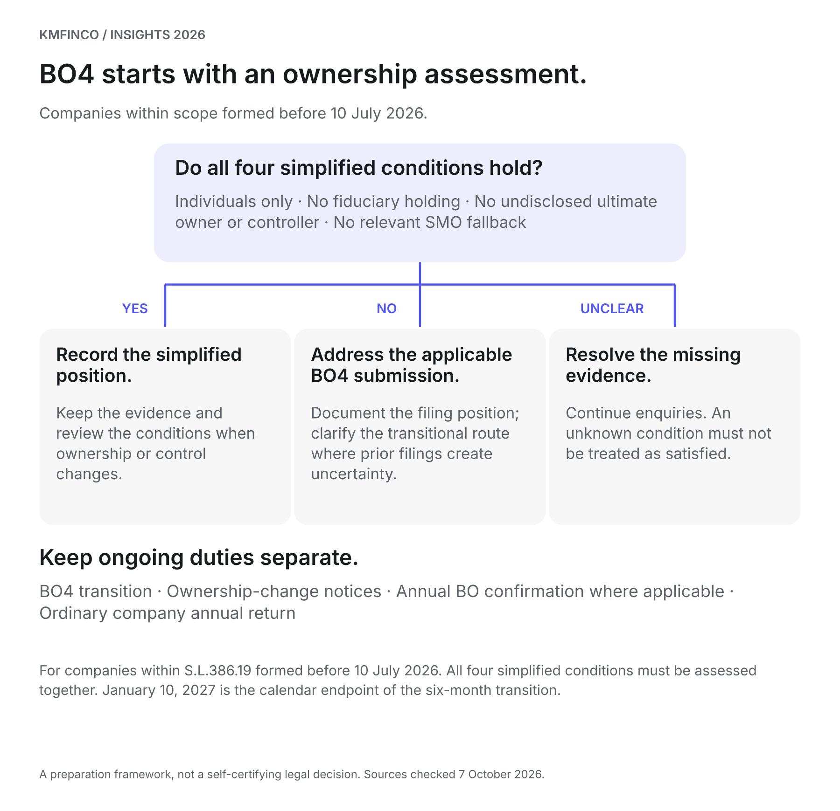
For companies within S.L.386.19 formed before 10 July 2026. All four simplified conditions must be assessed together. January 10, 2027 is the calendar endpoint of the six-month transition.
Evidence checklist

BO4 assessment and evidence checklist
An original internal preparation record for directors and company secretaries. It does not replace the prescribed form or establish eligibility by itself.
01 Confirm the entity is within the regulations and record its registration date.
Evidence: Current company extract and scope note, including any relevant listed-company exclusion.
Suggested owner: Company secretary and adviser
02 Reconcile registered ownership and voting rights.
Evidence: Register of members, constitutional documents, share movements and current ownership diagram.
Suggested owner: Company secretary
03 Identify fiduciary and nominee arrangements.
Evidence: Declarations and underlying agreements showing the capacity in which each holder acts.
Suggested owner: Shareholders and adviser
04 Investigate ultimate control beyond the register.
Evidence: Shareholder agreements, appointment rights, enquiry records and reasoned assessment.
Suggested owner: Director and adviser
05 Address any senior-managing-official fallback correctly.
Evidence: Record of exhausted enquiries, difficulties and basis for the identified official or officials where appropriate.
Suggested owner: Director and appropriate professional
06 Verify identifying particulars and effective dates.
Evidence: Identity records, place of birth, address, nationality, nominee details and dates of ownership changes.
Suggested owner: Company secretary
07 Record whether all four simplified conditions are met.
Evidence: Dated assessment, relevant provision, unresolved issues and any MBR clarification needed.
Suggested owner: Director or company secretary
08 Complete the applicable submission and retain evidence.
Evidence: Current form, officer's signature, filed version, acknowledgement and follow-up record.
Suggested owner: Authorised filer and signatory
09 Update the ongoing corporate calendar.
Evidence: Separate entries for reportable changes, annual BO confirmation where applicable and the ordinary annual return.
Suggested owner: Company secretary

Sources and further reading
Sources checked 7 October 2026. Source titles link to the original publications.
S1 Companies Act (Register of Beneficial Owners) Regulations — S.L.386.19, current consolidation — Consolidation accessed 2026-10-07
S2 MBR — Informative Note: Entry into force of legislation — 2026-07-13
S3 MBR — User Guidelines: Companies Act (Register of Beneficial Owners) (Amendment) Regulations, 2026 — 2026; accessed 2026-10-07
S4 Prevention of Money Laundering and Funding of Terrorism Regulations — S.L.373.01, regulation 2 — Consolidation accessed 2026-10-07
S5 MBR — Official Registry Forms — Accessed 2026-10-07
S6 MBR — Annual Filings — Accessed 2026-10-07
05 / TAX

VAT Registration in Malta in 2026: Article 10, Article 11 or Article 12?
Understand Malta’s domestic small-enterprise threshold, input-VAT trade-offs and cross-border purchases. Three practical examples show why Articles 10, 11 and 12 need to be assessed together.
KMFinco · 9 minute read · Sources checked 7 October 2026


Key takeaways
- The domestic SME threshold is €35,000; determine Malta turnover under the VAT rules and monitor it during the year.
- Article 11 removes VAT on covered sales but gives no input-VAT deduction for the exempt activity.
- Article 12 can accompany Article 11; the €10,000 intra-EU goods threshold does not apply to overseas services.
- A registration change requires the applicable conditions and effective date, including the rules for early conversion.
A Malta business can qualify for the small-enterprise exemption on its local sales and still have VAT to pay on services bought from abroad. That is why choosing a registration by turnover alone can leave an important part of the business unexamined.
Article 10 is the normal VAT registration framework. Article 11 concerns the domestic small-enterprise exemption. Article 12 addresses specified cross-border transactions for persons outside Article 10, and can sit alongside Article 11. The practical assessment starts with what you sell, where those supplies take place and what you purchase.
This guide covers the general rules checked on 7 October 2026. Its examples are hypothetical; property, financial services and other special transactions may need separate treatment.

Start with the purpose of each registration
MTCA’s registration guidance distinguishes the ordinary framework, the small-enterprise exemption and the obligations arising from relevant overseas purchases. The following table is an orientation; each supply still needs the correct VAT treatment. S1
Question | Article 10 | Article 11 | Article 12
Main purpose | Normal VAT registration. | Small-enterprise exemption for qualifying supplies in Malta. | Specified intra-EU acquisitions and cross-border services outside Article 10.
VAT on customer sales | Apply the relevant rate or exemption. | No VAT charged on supplies covered by the exemption. | Does not itself decide the treatment of the business’s sales.
VAT on business purchases | Deduction may be available, subject to the rules. | No input-VAT deduction for the exempt activity. | No input-VAT recovery merely because Article 12 VAT is paid.
Can it stand alongside Article 11? | The domestic Article 10/11 status is an alternative. | Yes, alongside Article 12 when required. | Yes; it can create an additional obligation.

The important distinction is between a supply’s treatment and the business’s registration. A normal registration does not make every sale taxable at 18%. Equally, a small-enterprise exemption does not remove the need to examine purchases.

What the €35,000 threshold means in 2026
The domestic small-enterprise threshold is €35,000, with no separate sectoral thresholds. These rules have applied since 1 January 2025. They are relevant in 2026, rather than a new 2026 threshold announcement. The European Commission confirms that Malta provides no transitional excess allowance when the national threshold is crossed. S2
At application, examine the preceding calendar year and whether the current year has already exceeded the limit. Monitor the current year after registration: the test cannot be left until annual accounts are prepared. MTCA’s guidelines explain how to determine eligibility and domestic turnover. S3
“Domestic” means supplies taking place in Malta under the VAT place-of-supply rules. It does not simply mean money received in a Maltese bank account or invoices issued by a Maltese company.
Use a turnover schedule that distinguishes:
- Supplies taking place in Malta from those taking place elsewhere.
- Taxable supplies, relevant exempt supplies and any excluded capital-asset disposals.
- The preceding calendar year from the current year to date.
- Any proportionate turnover that must be included under the related-person rules.
Certain exempt property, financial and insurance transactions can count unless ancillary. Conversely, a supply outside Malta for VAT purposes may not enter the domestic figure. A business with several activities should classify them before adding the numbers. S3

Shared ownership can affect the calculation
For persons other than natural persons applying for or using Article 11, the rules can require proportionate domestic turnover of related persons to be included. The statutory relationship test includes ownership or control above 10%; MTCA’s guidance explains its application and additional anti-abuse considerations. S3
A new company’s own sales ledger may therefore be insufficient evidence of eligibility. Collect the ownership structure and relevant business activities of the owners and connected entities, including indirect interests. Have the required proportions calculated rather than simply adding every connected business’s worldwide revenue.
This deserves attention when a sole practitioner incorporates, two consultants establish a partnership, or an owner separates activities into different companies. A new legal entity should trigger a fresh assessment of the facts; it should not be assumed to create a fresh unqualified €35,000 allowance.

Example 1: a freelancer buying overseas software
Hypothetical facts: a Malta-established freelancer validly uses Article 11 for local work and buys a €100 business software service from a supplier outside Malta. Assume the service is taxable in Malta, the freelancer is liable under the reverse charge and the applicable rate is 18%.
The resulting Maltese VAT is €18. With no input-tax deduction for the exempt activity, the total economic cost is €118: €100 to the supplier and €18 in Maltese VAT. The standard-rate assumption is consistent with Article 19 of the VAT Act. S4
The relevant Article 12 obligation does not wait for overseas services to reach €10,000. That figure concerns the specified intra-EU goods-acquisition threshold. MTCA separately identifies services received from overseas where Malta is the place of taxation and the customer is liable. S1
Before the first purchase, establish the supplier, service type, business use, correct VAT identification and invoice treatment. If a supplier has charged foreign VAT, investigate the invoice rather than assuming that payment settles every Maltese obligation. Keep subscriptions and advertising accounts in the purchase review; small recurring charges can otherwise escape notice.

Example 2: a retailer comparing prices and input VAT
Input-VAT recovery matters, but it is only one part of the commercial comparison.
Hypothetical assumptions: the business is eligible for Article 11; it sells one standard-rated item to a consumer for the same final price of €118 under either scenario; the item costs €60 plus €10.80 VAT; and the Article 10 scenario permits full deduction. All other costs and income tax are excluded.
Per item | Article 11 | Article 10
Final price paid by the customer | €118.00 | €118.00
Sales amount excluding any output VAT | €118.00 | €100.00
Purchase payment including VAT | €70.80 | €70.80
Recoverable purchase VAT | €0.00 | €10.80
Trading margin before other costs | €47.20 | €40.00

The ordinary-registration calculation is €100 revenue less €60 net purchase cost. The exempt-business calculation is €118 revenue less €70.80 purchase cost. Input recovery therefore does not, on its own, determine the better margin.
Change the assumptions and the comparison changes. A business customer with recovery rights may evaluate the price excluding deductible VAT. A major equipment purchase changes the input-tax profile. Growth may remove eligibility for the exemption. Model actual customers, prices and costs rather than selecting a registration because one column appears favourable in isolation.

Example 3: services supplied to an overseas business
Hypothetical facts: a Malta consultant supplies €20,000 of general business consultancy to a VAT-identified company in another EU Member State. Assume the general business-to-business place-of-supply rule applies, with no special rule or relevant fixed-establishment complication.
In that fact pattern, the supply takes place where the business customer is established. It does not become domestic Malta turnover simply because the consultant works from Malta. For a person registered under Article 11, supplying qualifying services in another Member State where the recipient alone pays VAT can create an Article 12 registration requirement. S3
Document the customer’s status and the nature of the service. An overseas address alone does not establish the answer, and a service to a private consumer may follow different rules. Identify any recapitulative reporting and invoice requirements associated with the actual transaction. The VAT Act’s registration and place-of-supply provisions provide the legal framework. S4

Where Articles 11A and 11B enter the picture
Cross-border SME exemption is a further question. Article 11A concerns Malta-established businesses seeking the small-enterprise exemption in other Member States. Article 11B concerns businesses established elsewhere in the EU seeking that exemption in Malta. S3
The EU framework requires Union turnover not exceeding €100,000 in both the current and previous calendar years, together with the relevant national thresholds and notification requirements. Exemption starts when the required EX identification and confirmation for the selected Member State are granted. There is also quarterly turnover reporting. S5
The €100,000 ceiling does not replace Malta’s €35,000 domestic test. Nor does a cross-border sale automatically require or qualify for the SME scheme. First determine where and how the transaction is taxed; then assess whether the relevant exemption is available and appropriate.

Switching registration: the 2026 portal change
On 29 May 2026, MTCA announced that requests to change between Article 10 and Article 11 can be submitted through the VAT e-Services portal. It says requests during the first 12 months and afterwards may be subject to different conditions, and that existing VAT obligations must be complied with. S6
The VAT Act contains a specific early-conversion provision: the Commissioner may accept an Article 10-to-11 request where the small-enterprise conditions are satisfied and no input-tax credits were claimed during the Article 10 period. This is a conditional route, not an automatic right to switch at any date chosen by the taxpayer. S4
Before changing invoice settings, establish the effective registration date. Reconcile filed returns, existing obligations and previous input-tax claims; review stock and capital assets with the accountant. Communicate the correct treatment to whoever issues invoices. A submitted portal request and an effective change in registration are different stages of the process.

Four practical questions

If turnover is below €35,000, can I simply issue invoices without VAT?
Establish eligibility and the required registration first. Confirm that the relevant supplies are covered and use the correct effective date. A turnover figure alone does not determine the treatment of earlier invoices or overseas transactions.

Can Article 11 and Article 12 both apply to my business?
Yes. Article 11 can cover qualifying domestic sales while Article 12 creates obligations on specified transactions. The overseas-software example illustrates why the sales and purchase reviews must be connected.

Do I wait until overseas services cost €10,000 before registering?
No. Do not transfer the intra-EU goods-acquisition threshold to services. Analyse where the service is taxable, who owes the VAT and the registration required before the relevant transaction. S1

Does Article 10 let me recover VAT on every expense?
No. Deduction depends on the applicable rules, business use, supporting evidence and any restrictions or exempt activity. The retailer illustration assumes full entitlement for the particular stock purchase; it is not a general rule for every cost. S4

Put the assessment into the monthly routine
A useful VAT review connects registration, sales classification, overseas purchases and turnover monitoring. Give someone responsibility for flagging a new activity, a large order or a foreign supplier before an incorrect treatment becomes routine.
Use the tax and finance calendar to record the reporting obligations that actually apply. KMFinco’s Tax, Accounting & Payroll service provides a relevant starting point for discussing the registrations, transactions and records your business needs to examine.
Visual guide

Three questions before choosing a VAT registration
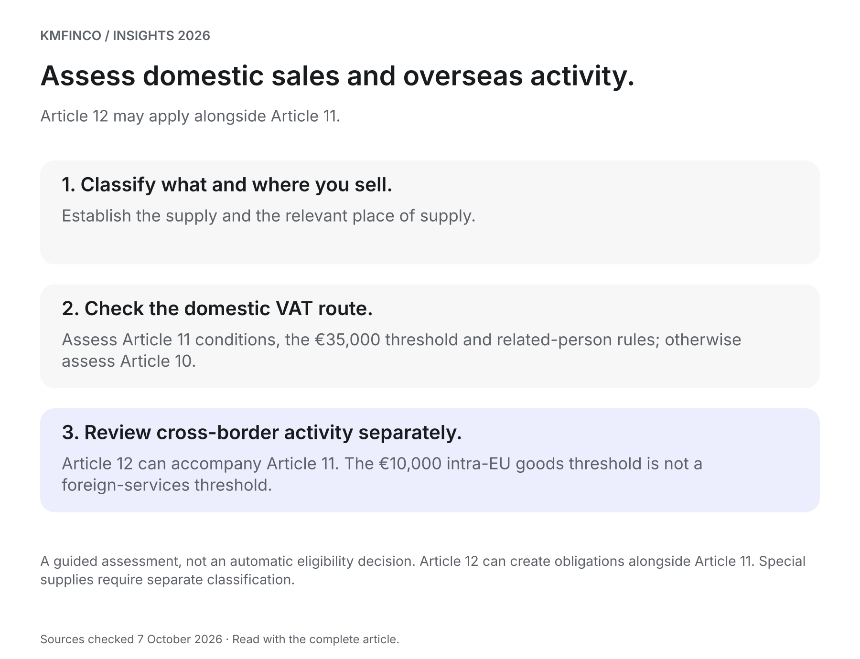
A guided assessment, not an automatic eligibility decision. Article 12 can create obligations alongside Article 11. Special supplies require separate classification.
Evidence checklist

VAT registration and transaction review
Use this original preparation checklist to connect the sales and purchase sides of the business. It is not an official registration form.
01 Confirm present registrations and effective dates.
Evidence: MTCA registration notices, recent returns and any pending change request.
Suggested owner: Finance lead
02 Classify sales by activity and place of supply.
Evidence: Contracts, invoice sample, customer business status and location analysis.
Suggested owner: VAT adviser
03 Prepare domestic turnover for both relevant years.
Evidence: Previous calendar year and current year-to-date schedules, with inclusions/exclusions explained.
Suggested owner: Bookkeeper and VAT adviser
04 Identify related-person turnover requirements.
Evidence: Ownership chart, indirect interests and relevant domestic turnover evidence.
Suggested owner: Directors and VAT adviser
05 Review overseas goods and services separately.
Evidence: Supplier register, acquisition totals, subscription invoices and reverse-charge assessment.
Suggested owner: Purchasing and finance
06 Model prices and input-VAT entitlement.
Evidence: Customer mix, VAT-inclusive/exclusive price list and purchase/capital expenditure plan.
Suggested owner: Finance lead
07 Implement the confirmed treatment and reporting calendar.
Evidence: Effective-date record, invoice settings, assigned returns and payment responsibilities.
Suggested owner: Finance lead

Sources and further reading
Sources checked 7 October 2026. Source titles link to the original publications.
S1 MTCA: Registration — Self-Employed, VAT registration under Articles 10, 11 and 12 — Current page checked 2026-10-07
S2 European Commission: Malta SME rules — Current page checked 2026-10-07
S3 MTCA: Guidelines in relation to the VAT rules applicable to small enterprises — 2025-04-07
S4 Value Added Tax Act, Chapter 406, Articles 10–12, 19 and 22; Third and Sixth Schedules — Consolidated text checked 2026-10-07
S5 European Commission: Cross-border SME scheme — Current page checked 2026-10-07
S6 MTCA: Changing the VAT Registration Type — 2026-05-29
06 / MANAGEMENT CONSULTING

AI in Professional Services: Who Signs Off?
From AI draft to reviewed client advice: a practical approval workflow for Malta’s accounting, tax, audit and advisory firms, illustrated through one fictional client memo.
KMFinco · 6 minute read · Sources checked 7 October 2026


Key takeaways
- Give AI a defined role in the deliverable and name the person responsible for professional review and release.
- Verify sources, dates, calculations and material omissions against independent evidence before relying on a draft.
- Keep a proportionate record of checks and conclusions, and control an agent's authority to send, file or change records.
- Measure total human effort and quality together when deciding whether an AI-assisted workflow is worthwhile.
AI can help a professional firm organise research, compare documents and prepare a clearer first draft. The value reaches the client when that work becomes a supported conclusion, approved by someone able to judge its substance.
For partners and managers, the central question is practical: what must happen between an AI-assisted draft and advice issued in the firm's name? Answering it makes adoption easier to manage and gives colleagues a repeatable way to use the technology.
The subject is timely in Malta. In September 2026, the Malta Institute of Accountants highlighted controlled AI use in everyday accounting workflows and the importance of governance and professional judgement. S1
This article proposes an operating framework, not a complete account of a firm's legal or professional obligations. Its examples are fictional. The FRC and ICAEW sources cited below concern UK audit practice and are used as professional references, rather than as statements of Maltese law.

Follow one client memo
Imagine a tax team preparing a memo about a client's planned transaction. An approved AI assistant organises the supplied facts, creates a list of questions and drafts an explanation with source links. The team can now spend its attention on missing evidence, competing interpretations and the client's choices.
One citation, however, comes from an archived official page. In this fictional scenario, the provision is genuine but was replaced before the relevant transaction date. Its wording has been reproduced accurately, while the resulting conclusion is wrong.
A useful workflow should catch that problem, correct the advice and preserve the basis for the correction. Four review stages make those responsibilities visible.

1. Approve the inputs and define the task
Before the file enters the tool, identify the approved environment, the client information needed and the permitted purpose. Check access, provider terms, retention arrangements and applicable confidentiality and data-protection requirements. Remove unnecessary identifying information where practical; anonymisation should be assessed carefully when remaining facts could identify the client.
For the memo, provide the transaction date, relevant jurisdictions and verified factual summary. Mark disputed or missing facts explicitly. Ask the assistant to distinguish supplied information from assumptions, identify its authorities and flag questions that require further evidence.
Keep the initial task bounded: research and prepare a working draft. An assistant does not need the client's entire archive or permission to email the client simply to help organise that work.
ICAEW's May 2026 audit guidance connects AI adoption with policies, training, oversight and protection of client information. Those themes are useful when designing a firm's own approved workflow. S2

2. Verify the substance against independent evidence
The preparer opens the cited official material, checks its current version and confirms when the relevant rule applies. That process exposes the archived provision in the fictional memo. The preparer replaces it, revises the analysis and explains why the original conclusion changed.
Source checking should ask more than whether a link opens. Does the authority cover this entity, period, transaction and jurisdiction? Does an exception alter its effect? Has the draft confused guidance with legislation or a proposal with an enacted requirement?
Recalculate material amounts using an appropriate independent method, with inputs traced to the client's records. A second AI response agreeing with the first does not by itself verify the answer.
The reviewer should also consider what is absent. A polished explanation can omit a material alternative, a missing document or an unresolved assumption. Build the review around the client's decision and the evidence it needs.
IESBA identifies technology-related considerations across competence, due care, objectivity, confidentiality and independence. That provides a professional foundation for substantive review. S3

3. Keep a useful record of the review
For the fictional memo, retain the verified facts, current authorities, material calculations, correction to the superseded provision and the final reasoning. Record who prepared and reviewed the work and how outstanding questions were resolved.
Documentation should let an appropriate colleague understand why the conclusion was accepted. Use a proportionate record of material AI involvement and the relevant tool or workflow version where available. Apply the engagement's retention requirements; avoid collecting unnecessary sensitive content merely to keep an indiscriminate prompt archive.
A short review record can cover:
Field | What it should establish
Task and scope | What AI was asked to assist with
Facts and authorities | Evidence used and date-sensitive checks
Material corrections | What changed and why
Open matters | Questions still requiring action
Review and release | Responsible people, approved version and date

The review is complete when the material questions are resolved or clearly reflected in the advice's scope. An unchecked box should never disappear simply because the draft is ready to format.

4. Authorise the outcome and control the next action
The designated approver reviews the corrected memo and authorises a particular version for a particular recipient and purpose. The releaser checks that the attachment is that version and that the accompanying message does not overstate the conclusion.
For an AI agent that coordinates several tasks, distinguish permission to research from permission to send advice, submit a return or amend client records. Define which actions require approval and enforce those limits in the workflow.
For this memo, a sensible initial arrangement allows the agent to prepare a draft email while holding external delivery for approval. If a tool reports an uncertain submission outcome, check the authoritative system before retrying an action that could create a duplicate.
The FRC's March 2026 guidance discusses review and oversight at selected control points in generative and agentic systems. The useful design question is where human judgement can detect a consequential error or control a consequential action. S4

Measure a completed deliverable
Pilot the workflow on a defined class of work with comparable scope and complexity. Track total human time, including preparation, checking, correction and approval. Record material errors caught, rework, escalations and any confidentiality or permission incidents.
Agree acceptance criteria before the pilot. If drafting becomes quicker but review becomes substantially harder, examine the source pack, task design or choice of use case. Expand only when the evidence supports both useful efficiency and acceptable quality. No universal percentage saving should be assumed.
Bring junior colleagues into verification and explain corrections. A successful pilot should strengthen their understanding of the work they will eventually review.

Frequently asked questions

Must a partner check every AI-generated sentence?
Design review proportionately to the task and the consequences of error. Name competent reviewers and an authorised approver. Material professional judgements and unresolved issues need attention at the appropriate level.

Should the firm tell clients it uses AI?
Establish the requirements arising from the engagement, applicable rules and data use. Make any explanation accurate about AI's role and the firm's review process. A generic disclosure does not make an unsuitable use appropriate.

Can an agent send or file autonomously?
Technical capability is only one consideration. Define the approved action, permitted data, authority, exceptions and recovery process. For the initial client-advice workflow here, retain an explicit release approval.

What should the firm try first?
Choose a bounded, repeatable task with accessible source material and an established review process. Compare completed work, including corrections, with the current method before extending the scope.

Make the approval process part of adoption
Choose one recurring deliverable and map the four stages: approved inputs, verified substance, recorded review and authorised release. Assign the roles, trial the workflow and use the results to improve it.
Discuss the process through KMFinco's Management Consulting service area. For related thinking on making checks useful to the business, read Using control evidence to improve performance.
Visual guide

From AI draft to approved client advice
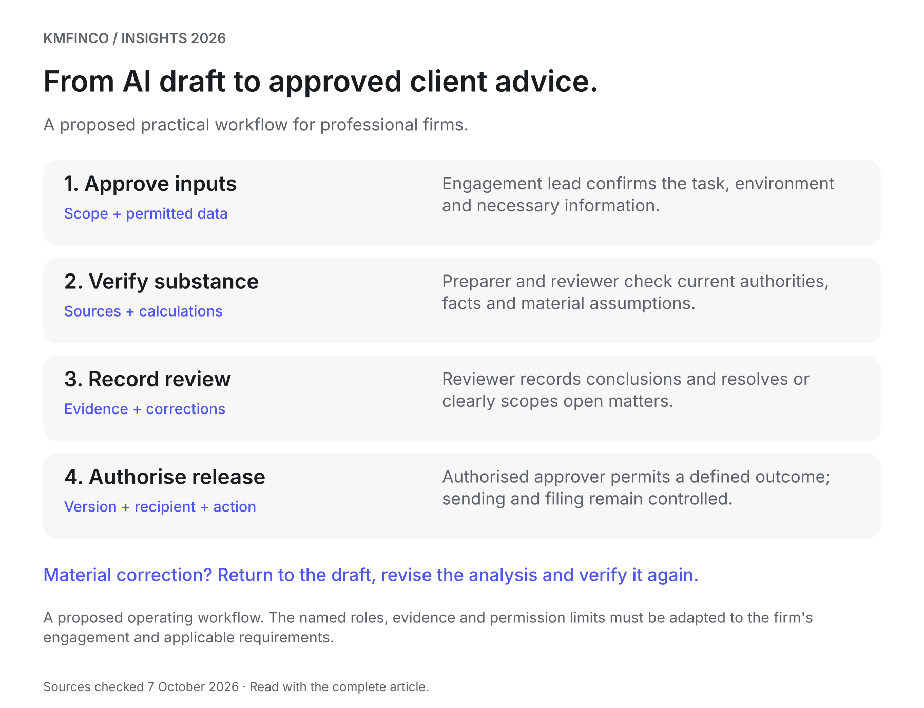
A proposed operating workflow. The named roles, evidence and permission limits must be adapted to the firm's engagement and applicable requirements.
Evidence checklist

AI-assisted client-work review checklist
Complete for the deliverable and retain evidence proportionate to its purpose, risk and engagement requirements. This is a practical aid, not proof of compliance.
01 Define the engagement and AI task
Evidence: Deliverable, client decision, permitted task and excluded actions
Suggested owner: Engagement lead
02 Approve the environment and information
Evidence: Approved tool, necessary access, permitted data use, provider and retention checks
Suggested owner: Engagement lead / designated technology or data owner
03 Confirm facts and current authorities
Evidence: Client evidence; source links; versions, dates and applicability checked
Suggested owner: Preparer / technical reviewer
04 Verify calculations and material assumptions
Evidence: Independent recalculation; traced inputs; resolved discrepancies and missing facts
Suggested owner: Preparer / reviewer
05 Challenge the proposed conclusion
Evidence: Material alternatives, omissions and specialist questions considered
Suggested owner: Competent reviewer
06 Record material corrections and open matters
Evidence: Review notes, evidence references, version history and outstanding actions
Suggested owner: Preparer / reviewer
07 Authorise the version and next action
Evidence: Approver, approved version, recipient, purpose and permitted send/file/change action
Suggested owner: Authorised approver
08 Confirm completion and capture learning
Evidence: Release or acceptance evidence; exceptions; total effort and quality observations
Suggested owner: Engagement lead

Sources and further reading
Sources checked 7 October 2026. Source titles link to the original publications.
S1 Malta Institute of Accountants: M26103 – Evolving Tools in the Accounting Profession — 2026-09-25
S2 ICAEW: Artificial intelligence in audit work – managing the risks — 2026-05-06
S3 IESBA: Technology – Ethics & Independence Considerations — Current page checked 2026-10-07
S4 FRC: Generative and Agentic AI Guidance — 2026-03

